The Glen Mhor Hotel
Job/Work Experience Interview
Social Story

The Glen Mhor Hotel – Job/Work Experience Interview
This is the Glen Mhor Hotel
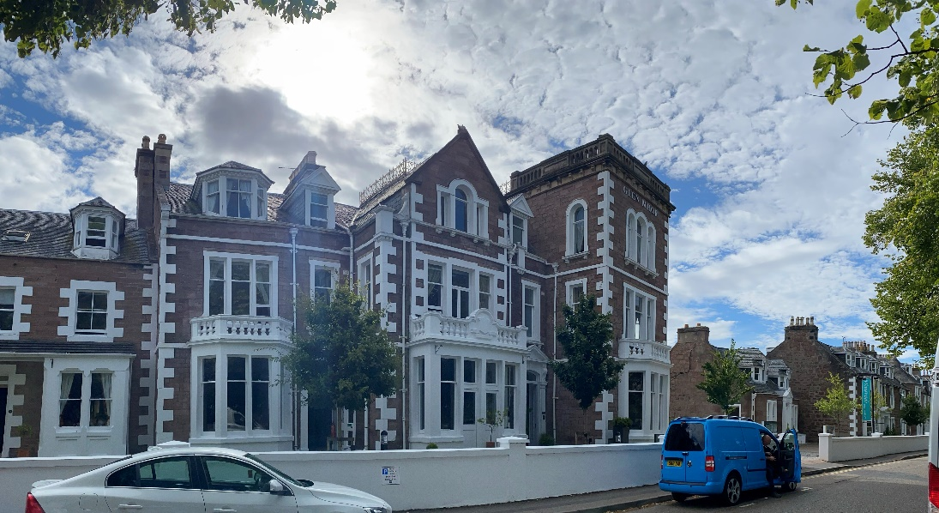

We are delighted that you are coming to see us today!
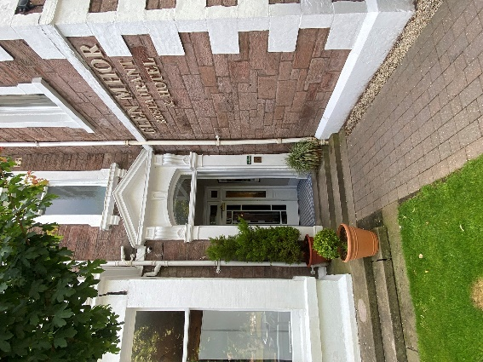
A job/work experience interview is where you can come and chat to us about a role you are interested in working in. It also allows you the chance to learn more about our hotel and to ask any questions you might have.
You can take a friend or family member to be with you to your interview/discussion if this would make you feel more comfortable.
You will already have been given a time to come to the Glen Mhor and meet with our HR manager Fiona Connor.
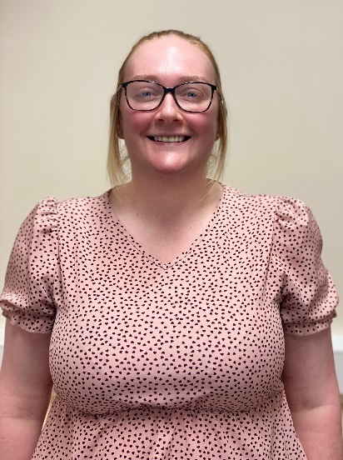
This is Fiona
Fiona will have let you know if anyone else will be with her for example our operations Manager or one of our Heads of Department. This will depend on the area of the hotel you are interested in working. Fiona can send you pictures of these people in advance if you would like this.
Our departments are: Management/Administration, Housekeeping, Reception, Service, Maintenance, Kitchen & Sales and Brewery/Distillery staff.

Before you arrive, you can tell Fiona if you would like to sit down for your discussion or if moving around or walking around the hotel would be best for you.
At the start of an interview, sometimes people shake hands to say welcome. If you are uncomfortable with this, please let Fiona know. We understand the sensitivities around touch.
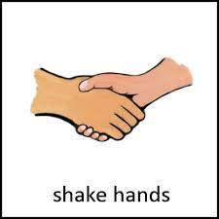
Shake Hands Or No Shaking Hands

On the day and time of your interview, you will go to our main reception lobby.
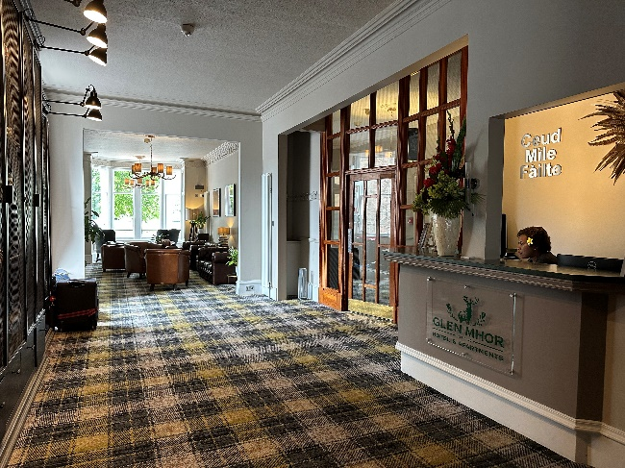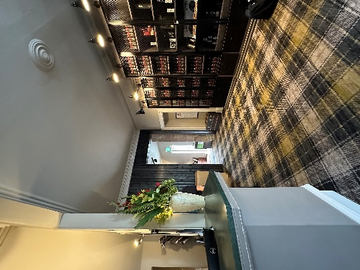
The receptionist will tell Fiona you are here. The reception might be crowded. It might be noisy, but you will not wait long.
Fiona will introduce herself and take you to where the interview discussion will take place - you will have told Fiona before your interview discussion where is best for you.
This could be:
A quiet room Walking around the hotel
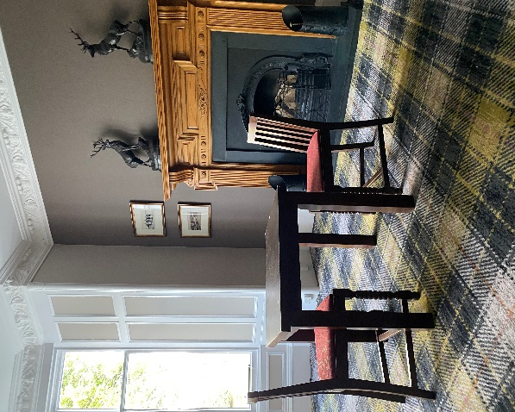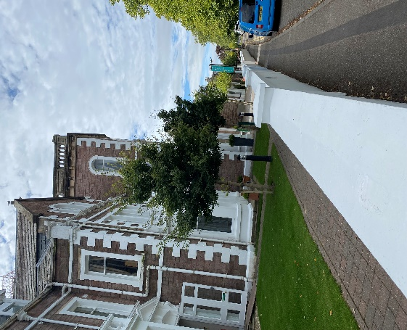
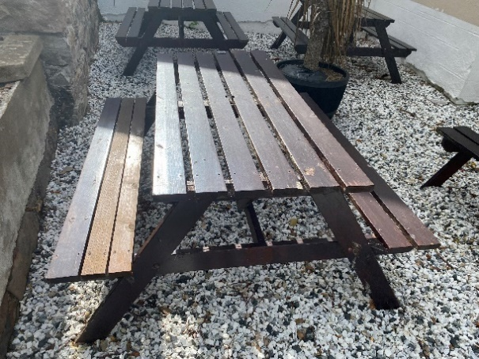
Sitting Outside

Fiona will start by telling you about the role we have, the tasks involved and the working hours.
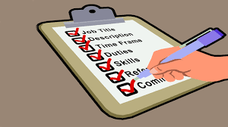

You can ask Fiona any questions you have on the role at any point.
Fiona will then ask about your experience or interest in this role. This is your chance to tell us about yourself, your experience, and your reasons for wanting to work for us.

If you feel uncomfortable at any time, you can take a break.

When you have finished your interview discussion, Fiona will ask if you have any final questions on the role.

At the end Fiona will take you back to reception where she will say Goodbye and thank you for coming to the interview.
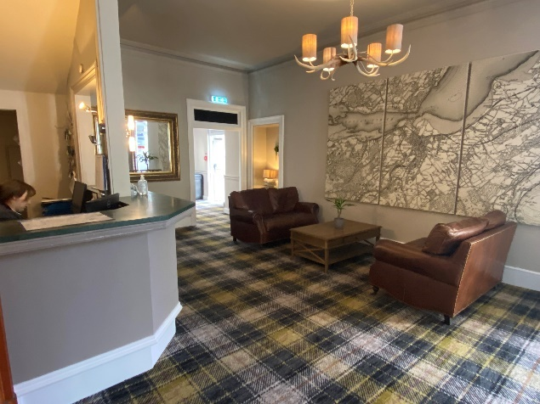

You will then return home.
Fiona will get in touch with you by phone the following day and give you feedback on your interview discussion. She will also explain the next steps.
Thank you for coming to the Glen Mhor for an interview.

