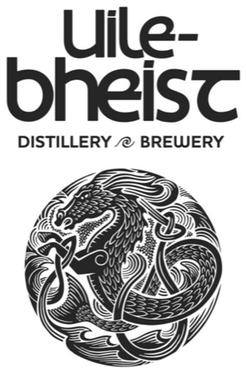

Uile-Bheist
Visiting our Brewery/Distillery
A Social Story

Welcome
This is Uile-Bheist Brewery and Distillery.
It is located within the Glen Mhor Hotel Complex in Inverness.
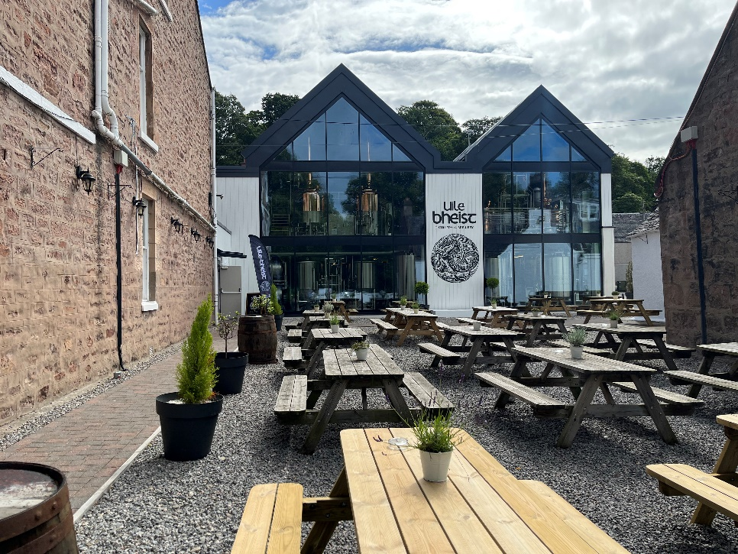
Uile-Bheist is pronounced Ewl-Uh-Vhest and means ‘Monster’ in Gaelic.

Uile-Bheist is sometimes called a brewstillery – this means that it is both a brewery and distillery. We make beer and whisky at Uile-Bheist.
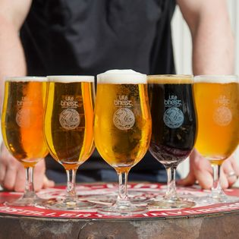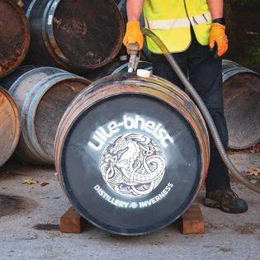

You will travel here with family or friends by car, bus, train, plane or bike.
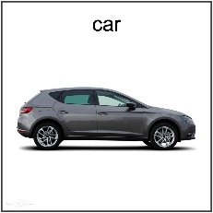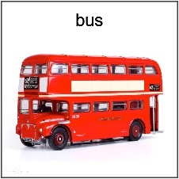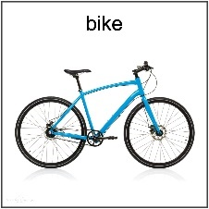
You might even walk here.

First you will arrive and wait in the reception lobby located in the Glen Mhor hotel. It might be crowded. It might be noisy, but you will not wait long. One of our friendly tour guides will meet you and introduce themselves.
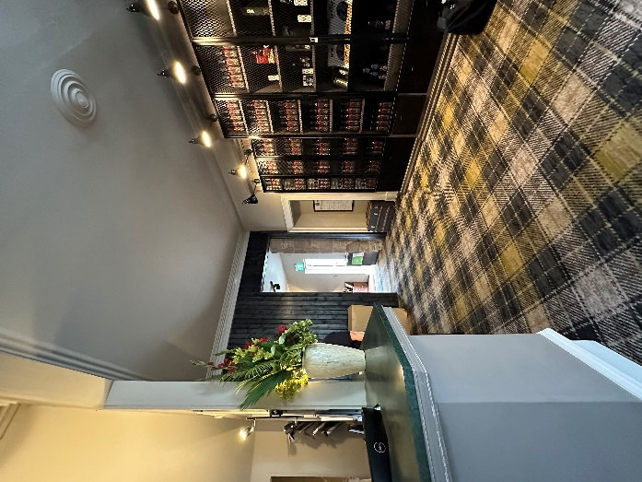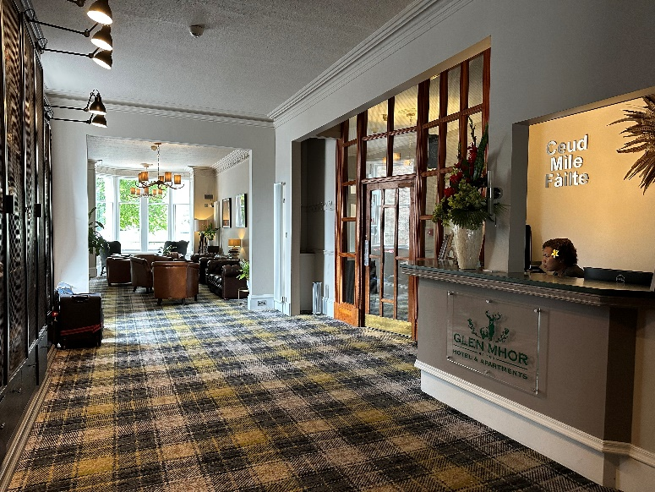

At reception, we have ear defenders you can borrow or a sensory backpack to explore while you visit.
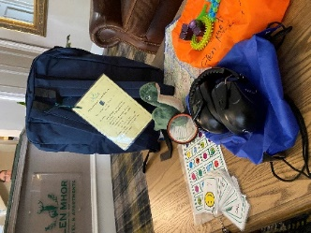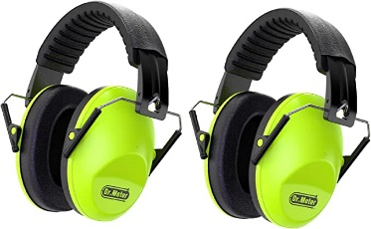

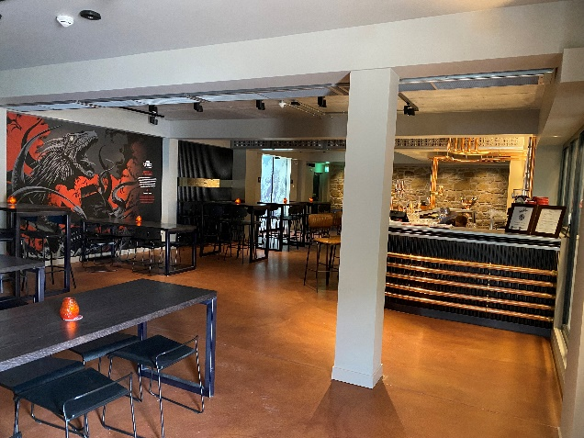
You will then make your way to our taproom – this is situated next to our reception area.
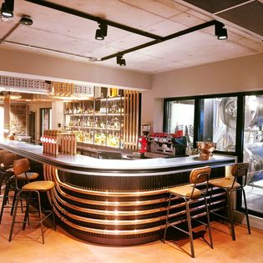

With our tour guide and your family or friends, you will explore and learn about how a brewery and distillery work – how this looks, feels, smells and sounds.

Our toilets are in the taproom area.
You can use them at any time during your visit.
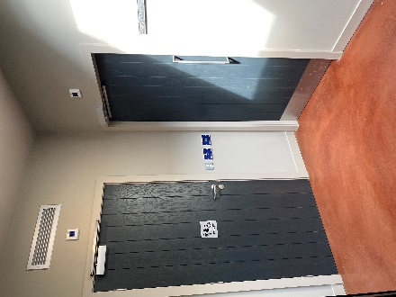
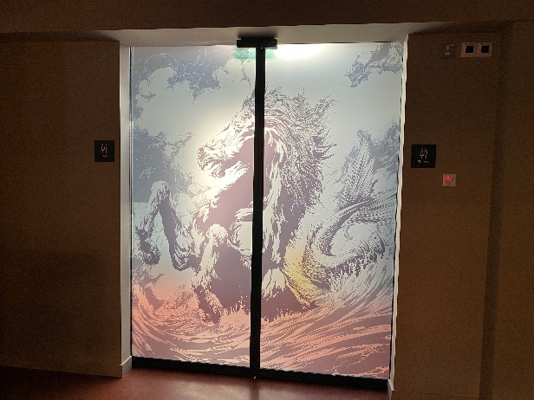

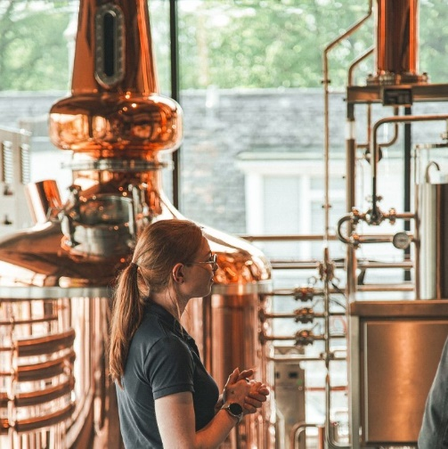
Our tour guides are very experienced and will be happy to answer any questions you might have about the taproom or Uile-Bheist as you go through your tour.

There are windows in our taproom where you can see the beer and whisky tanks and machinery and watch part of the process. Your tour guide will tell you all about the machinery and what is happening.
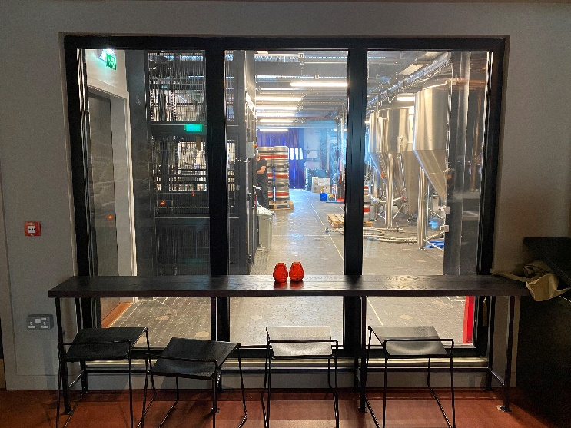
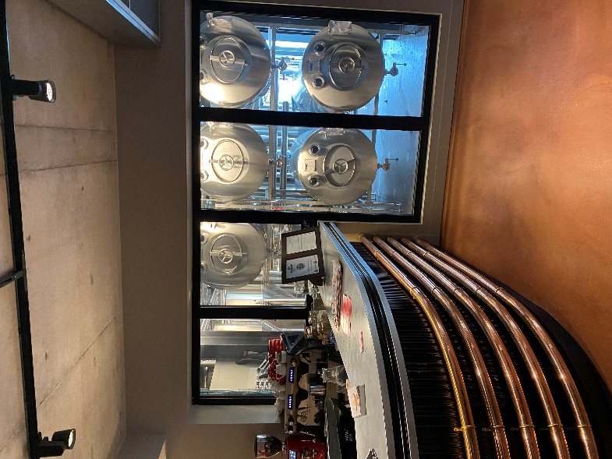

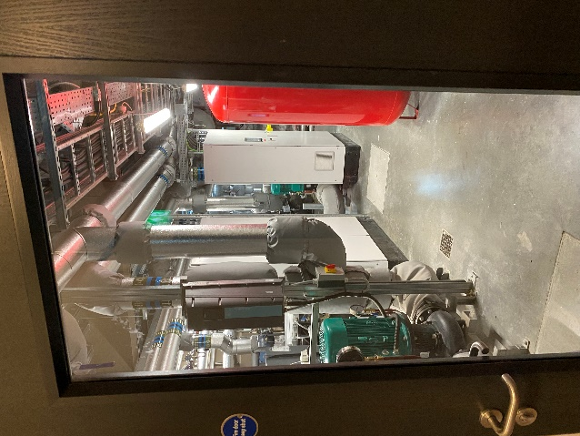
We are passionate about helping the environment and ensuring that we are responsible and supporting climate action. We also have our own energy centre which is at the back of Uile-Bheist. You will be able to see this through a glass door. The whole system is helping us save over 250 tonnes of carbon each year!

We have wells in our car park and we extract the heat from the water and use this to provide all the heat and water we need. We also have solar panels on the roof at Uile-Bheist to help support the energy needed to run all the machinery. We are very proud of our energy centre.
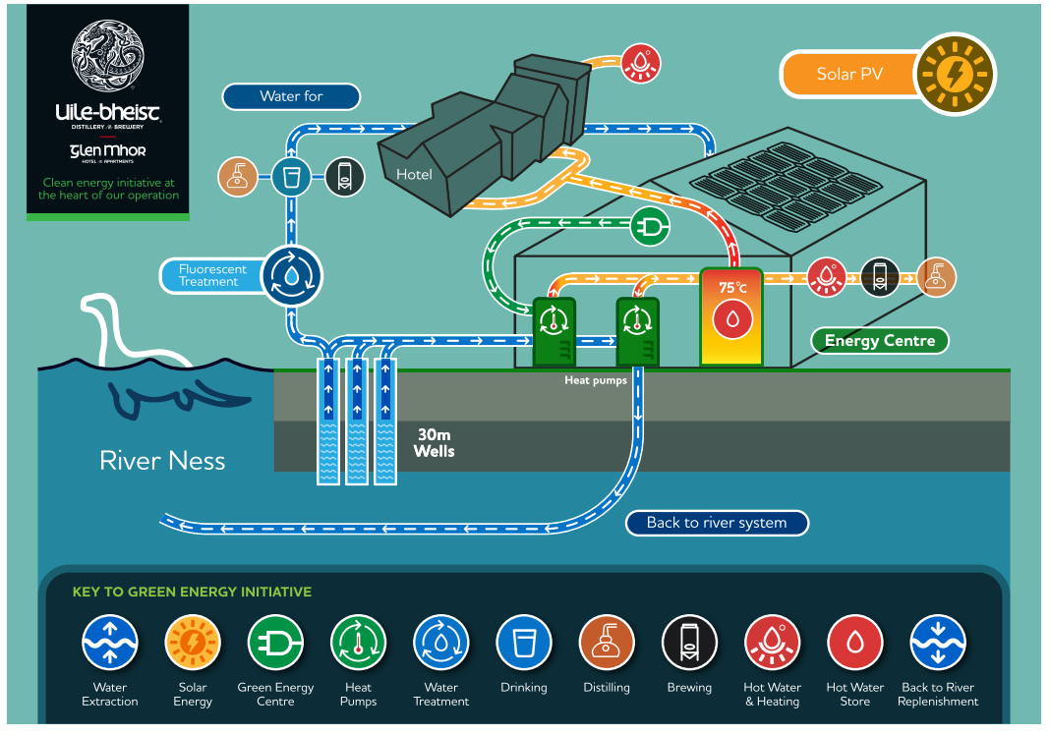

Your tour guide will explain all about the brewing and distilling techniques that our head brewery and master distillery use.
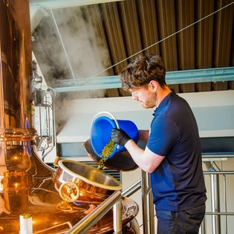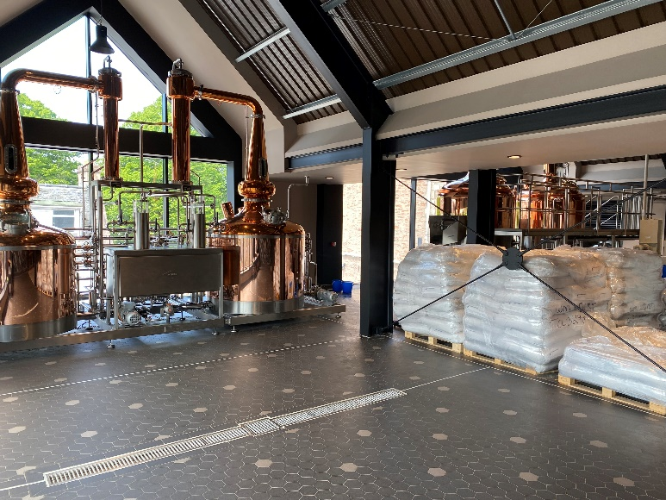

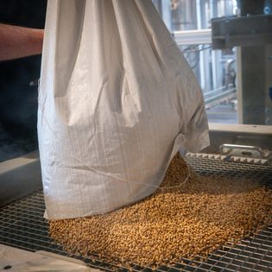
You will also see all the local produce we use to make our beer and whisky – including how we use our own water.
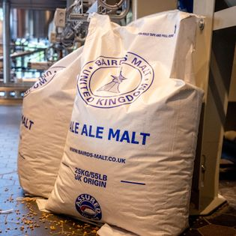
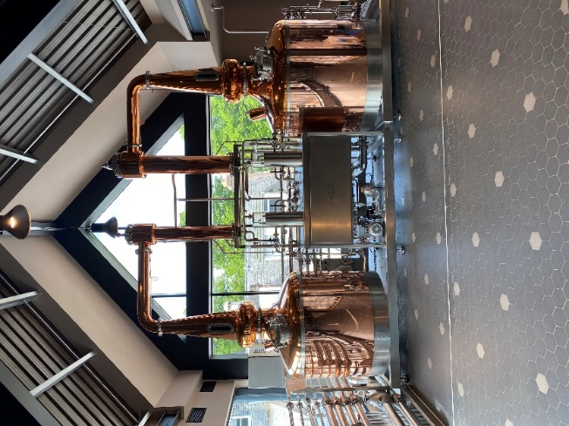

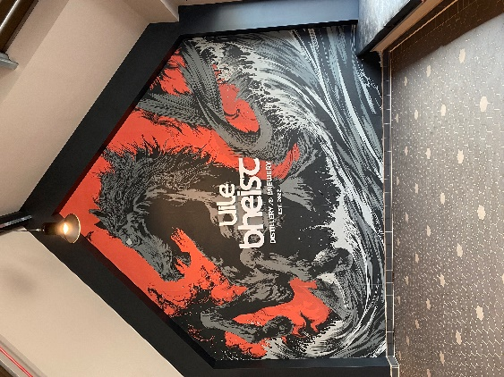
Our tour guides will also tell you all about the five characters that we have around Uile-Bheist and the stories behind each one.
Each character is from traditional Scottish mythological folklore and is the name for each of our five beers.
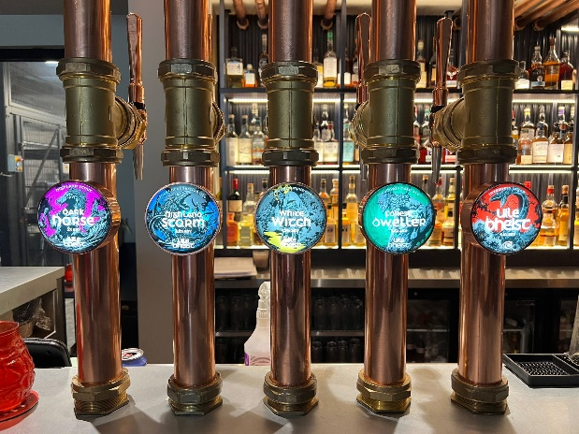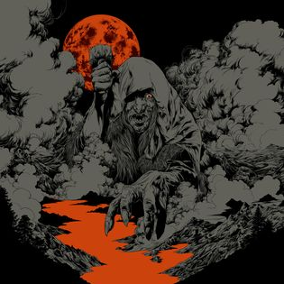

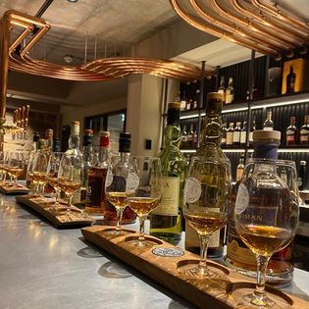
At the end of your tour and if you are over 18yrs you can sample our beer and local whisky. Each beer is different and each one delicious. Your guide will talk you through each one so you know what it will taste and smell like.
You can feel safe at Uile-Bheist. You will have a lot of fun.
After your tour is over, you will return home or to where you are staying if you are on holiday.
Goodbye - Thank you for visiting us at Uile-Bheist.

