Glen Mhor Hotel
Staying in a Hotel Room
A Social Story

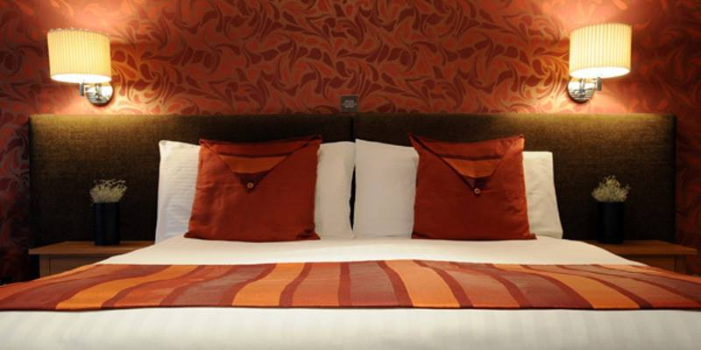

Welcome
This is the Glen Mhor Hotel - You will stay here for a visit.
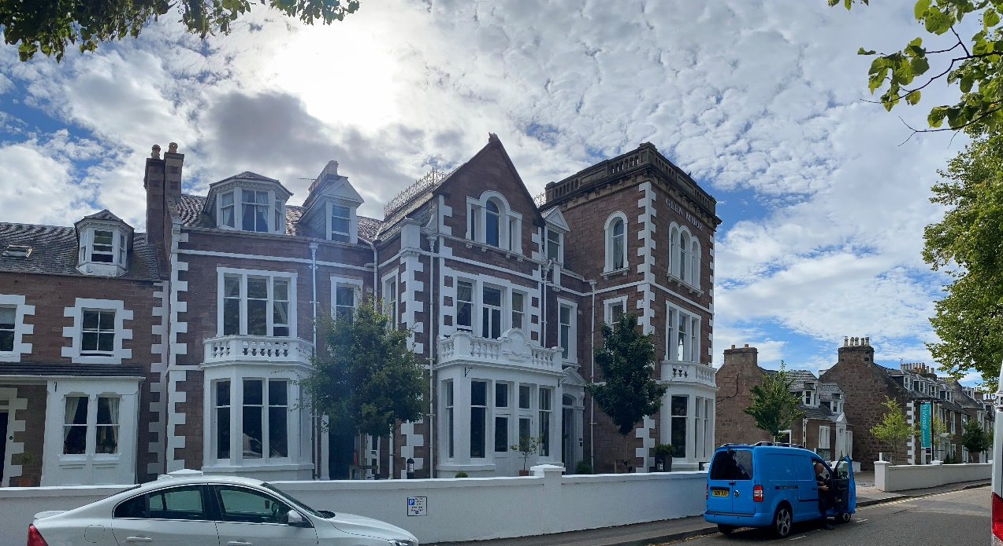

You will travel with family or friends by car, bus, train, plane or bike.
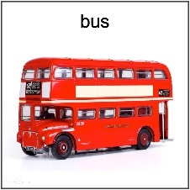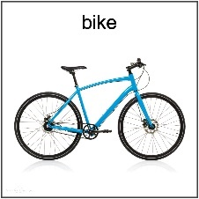
You might even walk here.
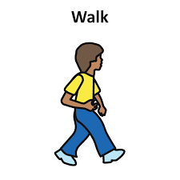

A hotel room is where you sleep, wash, get dressed and keep some of your things while you travel.

First you will arrive and wait in the reception lobby to check in. It might be crowded. It might be noisy, but you will not wait long.
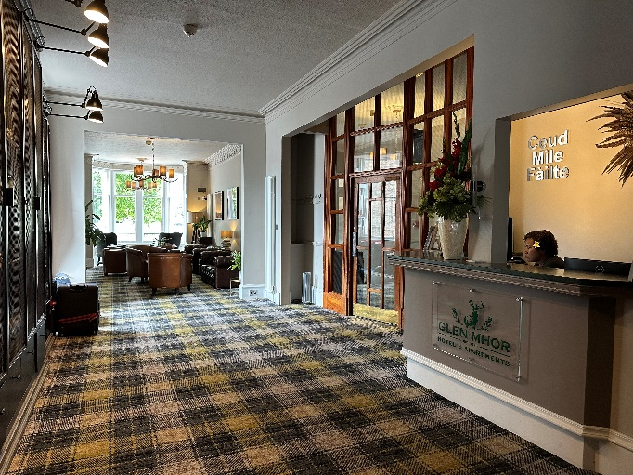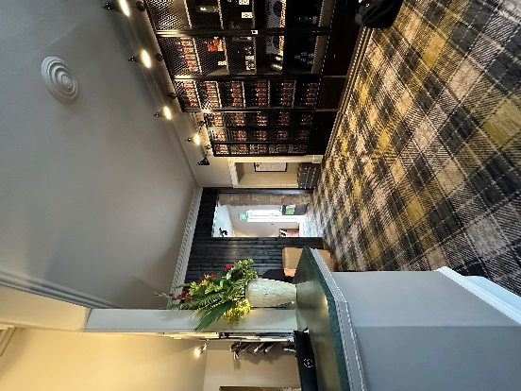
At reception, we have ear defenders you can borrow or a sensory backpack to explore while you visit.
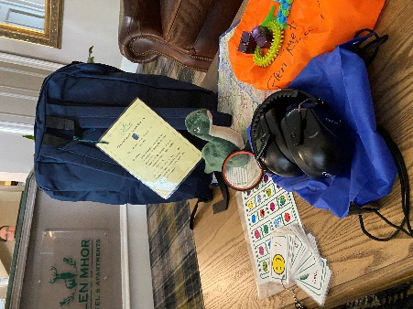

You will then make your way down new hallways and maybe some stairs to get to your hotel room. This will not take long.
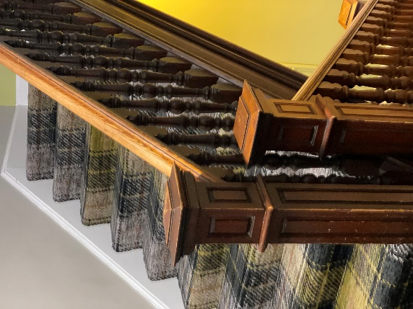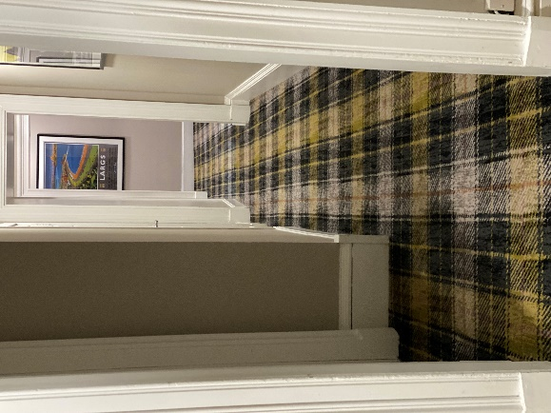

Next you will go into your hotel room with your family or friends. You will use a key card to open your room.
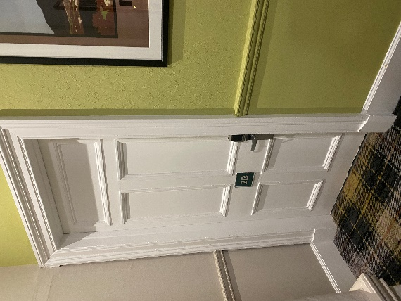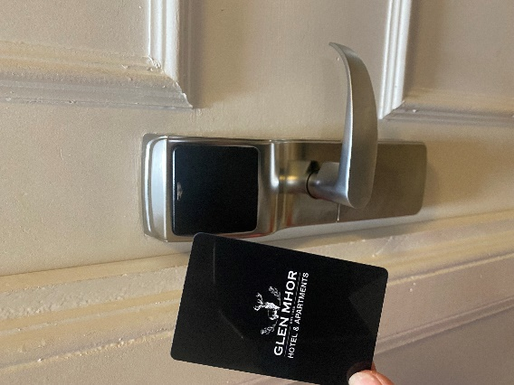

It will be different from you room at home but you will be able to sleep, wash, get dressed and keep some of your things from home that you brought with you.

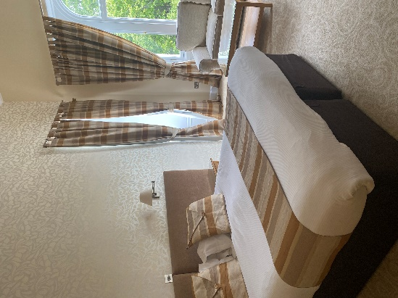

With your family or friends, you will explore how your hotel room looks, feels and sounds.
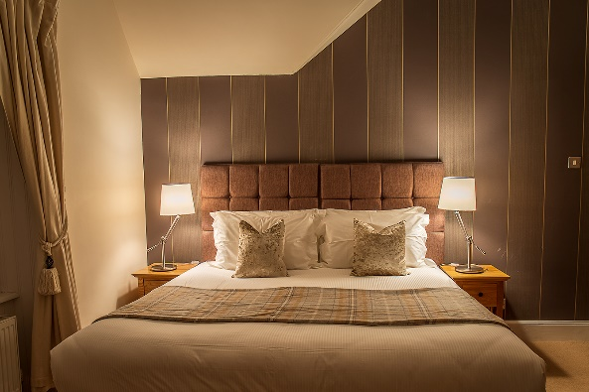

You can feel safe at the Glen Mhor and your hotel room.
You will have a lot of fun.
All our staff are friendly and happy to answer any questions you might have or help you during your stay.

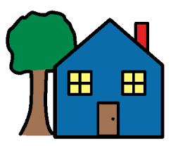

After your stay, you will return home with all your things that you brought.
Goodbye - Thank you for visiting us at the Glen Mhor.

